[Insert your logo]

My Attendance SUCCESS PLAN

Possible Strategies to REACH MY Attendance Goals

- I will make attending school and every class on time every day a priority.
- I will keep track of my attendance and absences and can use the attached calendar.
- I will maintain a bedtime routine and set my alarm for ______ a.m.
- I will find a relative, friend or neighbor who can take me to school if I miss my bus.
- When I am struggling with a challenge that is keeping me from school, I will confide in an adult at school and seek help. I can list adults and friends on the Help Bank (attached).
- I will try to set up medical and dental appointments for weekdays after school.
- I will attend school every day unless I’m sick with a contagious illness, including Covid-19.
- If I cannot avoid missing school, I will contact my teachers to ask for materials and find out what I missed.

To improve my attendance, I commit to the following:
1.
2.
3.

We will review progress to meet this goal in one month.

Student Signature: Date:

School Staff Signature: Date:
MY HELP BANK
CREATE BACKUP PLANS FOR GETTING TO SCHOOL
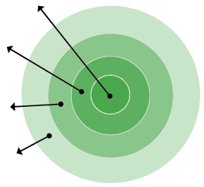
- My Family: List who lives in your house.
- Everyday Helpers: Identify who you can call on to help you get to school or resolve a problem. These are people like friends, neighbors, school staff, and relatives who can help regularly.
- Occasional Helpers: Identify people who probably cannot help every day, but can help in a pinch. Maybe it’s a godparent, a relative or a friend who lives outside your neighborhood but can be there for short stints.
- Potential Helpers: Identify people who are part of your school community, place of worship or neighborhood who are able to help if you ask.
MY FAMILY
POTENTIAL HELPERS
EVERYDAY HELPERS
OCCASIONAL HELPERS

- My Family:
- Everyday Helpers:
- Occasional Helpers:
- Potential Helpers:
If I need help getting to and from school or with a barrier to attendance, I will ask the following people to help me out:

Name: Best Contact Number:
Name: Best Contact Number:

Name: Best Contact Number:

