School Transitions Planning Worksheet
For the Covid-19 Era

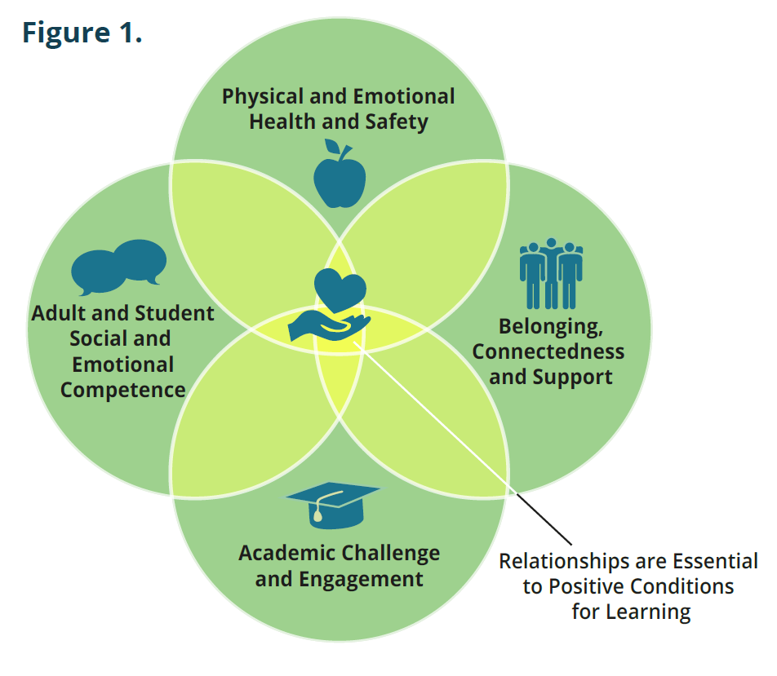
Purpose of the worksheet
Data on attendance and absenteeism are essential tools for creating a thoughtful plan for managing multiple school transitions. Data sheds light on where additional investments are needed to ensure that positive conditions for learning (see Figure 1) are in place to motivate students to show up to school, regardless of whether classes are offered in person, through distance learning or blended.

How to use this worksheet
This worksheet poses six key questions for school leaders to answer as they prepare a plan for managing school transitions. It supports each school creating a plan tailored to their realities especially since the impact of Covid-19 varies. It emphasizes understanding and inviting feedback from the students and families most impacted in your school (Black, Latinx, Native American, economically disadvantaged, students with disabilities) to ensure the plan addresses their needs.

The worksheet is intended to help school leaders attend to the most urgent questions first. Each question is followed by a few statements that lay out priorities for implementation. This worksheet can be used to develop or revise an existing transition plan.

This worksheet is not meant to be an in-depth analysis of a school’s system. If you are interested in a more intensive analysis, consider piloting Present, Engaged and Supported: School Transition Planning Guide for PreK-5 and School Transition Planning Guide for Grades 6-12 and the accompanying Transition Attendance Analysis Tools.

As school leaders, we suggest consulting with key stakeholders including staff, families and community partners to determine how your school can best respond. Use the blank worksheet on page 3 to keep track of what you are already doing. Then identify and address additional priorities that may be missing that require action.

Finally, we offer these resources which you may find helpful as you determine priorities for action:

- Monitoring Attendance in Distance and Blended Learning by Attendance Works
- Attendance Playbook: Smart Strategies for Reducing Chronic Absence in the Covid Era by Future Ed and Attendance Works
- When Learning Starts: Playbook for Healthy School Communities by Kaiser Permanente
- Guidance on Culturally Responsive Sustaining Remote Education Centering Equity, Access, and Educational Justice for more information visit
New York State Department of Education’s resources on this topic.

Key Questions | Priorities for Implementation (School)
- Do we have a team with responsibility for transition planning in place? | - Establish or expand the school team to include instructional, non-instructional school staff and community partners.  - At the elementary school, reach out to preschool providers serving the families who attend your school.  - Engage site administrators and school staff in the design of the plan, and determine who will implement the plan.  - Ensure the perspectives and experiences of students and families inform the plan, especially those most affected by Covid-19 and existing educational inequities.
- What will our school do to provide a physically and emotionally healthy environment in the current school year that emphasizes restorative and trauma-informed strategies? | - Follow district guidelines to prevent and mitigate the spread of Covid-19.  - Map school-based behavioral and mental health resources.  - Know how to access behavioral and mental health resources from the district and community partners.  - Ensure school-wide and classroom level routines and practices support positive, welcoming school climate and culture, whether that is in-person, hybrid or virtual.  - Keep in mind the value of offering playful activities that build community and make coming back to school fun!  - Equip staff to recognize and respond to trauma and stress-related behaviors and to use restorative practices.  - Address the disparate impact of Covid-19 on the members of the school community who are Black, Latinx, Native American, and students with disabilities, living in low-income rural communities, and involved in public systems. Identify gaps in resources.  - Create time during staff or grade-level meetings (e.g. advisory periods in secondary grades) to support these activities.
- Based on data, can we anticipate which groups of students are in need of additional support? | - Analyze pre-Covid-19 attendance data by school, grade, race/ethnicity, home language, disability and zip code.  - Determine how many students & families that staff were unable to contact during school closure and reach out to them.  - Disaggregate quantitative and qualitative data to understand which students have not been participating regularly in distance learning since the opening of school, reach out to them and find out what is keeping them from participating (including lack of connectivity).  - Conduct a needs assessment for all young people flagged by the data analysis to update and identify barriers to attendance and participation.
- Do we have systems in place to ensure the students with the greatest needs receive the support and resources they need to connect and re-engage? | - Organize and facilitate a school-wide attendance strategy.  - Take a multi-tiered approach to reducing absenteeism that focuses on problem-solving and is non-punitive.  - Modify interventions in response to Covid-19.  - Plan for unique needs in key transition grades (K, 6th, 9th and 12th).
- Do we have a plan for monitoring attendance during the current school year? | - Expand how we track attendance with measures that assess contact, connectivity, participation and relationships.  - Train teachers, substitutes, and front office staff on new processes for taking attendance and updating contact information for every family.  - Administrators check that teachers and front office staff take daily attendance in 2020-2021, enter it into the student information system, track by mode of instruction (in-person, synchronous, asynchronous) and ensure consistency.  - Designate and train staff to identify and ensure connectivity issues for students and staff are resolved.  - Monitor absences in 2020-2021 and use the data for early warning.
- Do we have a communications strategy? | - Communications are targeted and accessible to diverse stakeholders (e.g., families, students, community partners, etc.)  - Draw upon district communications and tailor for the school.  - Maintain two-way communication with families and with staff using a variety of methods.  - Inform families in their home language when students are absent or not participating in distance learning.  - Use multiple modes of communication including social media, the website, email and text messages.

Key Questions | Priorities for Implementation (School)
- Do we have a team in place with responsibility for transition planning?
- What will our school do to provide a physically and emotionally healthy environment in the current school year that emphasizes restorative and trauma-informed strategies?
- Based on data, can we anticipate which groups of students are in need of additional support?
- Do we have systems in place to ensure the students with the greatest needs receive the support and resources they need to connect and re-engage?
- Do we have a plan for monitoring attendance in the current school year?
- Do we have a communications strategy?

