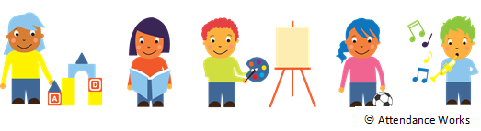

My Child’s Attendance SUCCESS PLAN

Possible Strategies to Reach MY Child’s Attendance Goals AND HELP MY CHILD GAIN THE SKILLS TO DO WELL IN SCHOOL and TO ReAD by 3rd GRADE.

* Keep an attendance chart at home to track absences. Consider using the attached calendar.
* At the end of the week, I will recognize my child for attending preschool every day with  
   . (i.e., a visit to the park, a new book, a special treat, a hug etc.)
* Make sure my child is in bed by p.m. and the alarm clock is set for a.m.
* Find a relative, friend or neighbor who can take my child to or from preschool if I can’t. I can list who can help on the Help Bank (attached).
* Set up medical and dental appointments for weekdays after preschool.
* If my child has a slight stomachache, headache or allergies and is not sick with a contagious illness including Covid-19, I will send my child to school. I will call the school or a health provider for advice if my child complains regularly.

To improve ______________________’s attendance, I commit to the following:

1. ____________________________________________________________________
2. ____________________________________________________________________

To improve ______________________’s attendance, the program commits to:

1. _____________________________________________________________________

2. _____________________________________________________________________

*We will review progress to meet this goal in one month.*

Family Signature: Date:

Program Signature: Date:

**To learn more, please visit www.attendanceworks.org**

Adapted from materials created by Early Works at Earl Boyles Elementary School in Portland, Oregon (<http://www.childinst.org/our-initiatives/early-works>)

*rev. 9-8-21*

**MY FAMILy’S HELP BANK**

**CREATE BACKUP PLANS FOR GETTING TO SCHOOL**

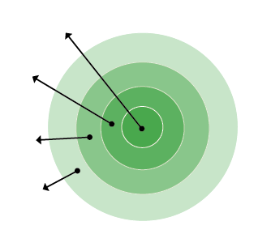

1. **My Family**: List who lives in your house.
2. **Everyday Helpers**: Identify who you can call on to help drop your child off or who can pick your child up when you cannot. These are people like friends, neighbors and relatives who can help regularly.
3. **Occasional Helpers**: Identify people who probably cannot help every day but can help in a pinch. Maybe it’s a godparent, a relative or a friend who lives outside your neighborhood but can be there for short stints.
4. **Potential Helpers**: Identify people who are part of your school community, place of worship or neighborhood who are able to help if you ask.

**EVERYDAY HELPERS**

**MY FAMILY**

**POTENTIAL HELPERS**

**OCCASIONAL HELPERS**

1. **My Family**:
2. **Everyday Helpers**:
3. **Occasional Helpers**:
4. **Potential Helpers**:

If I need help getting my child to and from school, I will ask the following people to be our backup:

**Name:** **Best Contact Number:   
  
Name:** **Best Contact Number:**

**Name:** **Best Contact Number:**

