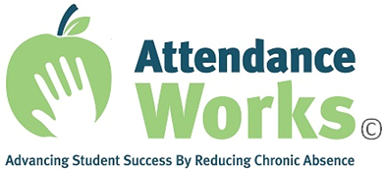

Dear (Insert name):

We are partnering with Attendance Works on the national Attendance Awareness Campaign 2019. The theme this year is “We belong in School!” As in past years, the Campaign includes a Superintendents Call to Action. Last year, 673 local superintendents in 45 states joined and made a public commitment to making attendance a priority, mobilizing the community and driving with data.

If you have already signed on to the Superintendents Call to Action, thank you!

If you haven’t, please consider making your leadership visible by signing on here. Attendance Works has developed tips and downloadable resources to help you and your team tackle chronic absence. Find them on the Attendance Works website page for Superintendents.

If you sign on by October 7, 2019, your name and district will be included in a press release sharing the names of all the superintendents who joined the national Superintendents Call to Action.

If you can’t recall if you participated, you can check the list of the superintendents who signed on last year, on the Attendance Works website.

Please join us in this effort to guarantee that all students have a chance to learn and succeed by making sure every day counts, starting in kindergarten!

Sincerely,

(Insert your name)

