[Insert your logo]

MY HELP BANK
CREATE BACKUP PLANS FOR GETTING TO SCHOOL
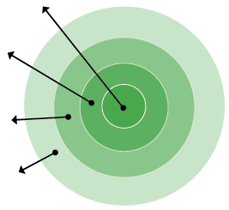
- My Family: List who lives in your house.
- Everyday Helpers: Identify who you can call on to help you get to school or resolve a problem. These are people like friends, neighbors, school staff, and relatives who can help regularly.
- Occasional Helpers: Identify people who probably cannot help every day, but can help in a pinch. Maybe it’s a godparent, a relative or a friend who lives outside your neighborhood but can be there for short stints.
- Potential Helpers: Identify people who are part of your school community, place of worship or neighborhood who are able to help if you ask.
MY FAMILY
POTENTIAL HELPERS
EVERYDAY HELPERS
OCCASIONAL HELPERS

- My Family:
- Everyday Helpers:
- Occasional Helpers:
- Potential Helpers:
If I need help getting to and from school or with a barrier to attendance, I will ask the following people to help me out:

Name: Best Contact Number:
Name: Best Contact Number:

Name: Best Contact Number:

