School Name
Address
Phone
Email
Principal
AP

Dear Parents/Guardians:

School Name has been analyzing attendance patterns and we have determined that your child is chronically absent (missed 10% of school or more). Below is an illustration of your student’s current number of absences as compared to the average student in grade level at school name. We are worried that if your child continues to miss schools’ days, it will be difficult to stay on track in the classroom.

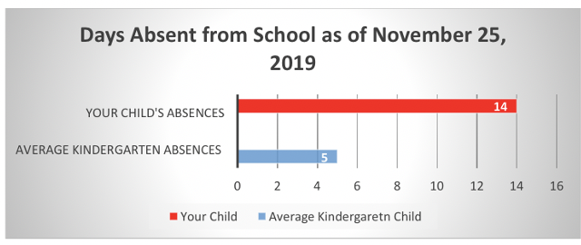

We are here to support you getting your child to school on time, everyday. Regular attendance is the most important piece in ensuring that your child can be engaged in learning and reach his or her full potential. We do realize that all families face challenges. Please let our school staff know if your family needs help dealing with a challenge to your child’s regular school attendance.
Also, please provide us with a written excuse note or medical documentation stating the reason for your child’s absence. We have attached a sample written excuse note for your reference.

Thank you for all you do to support your child’s school success and well-being. Best wishes for a successful rest of the school year.

Sincerely,

Principal name

