MY FAMILY’S HELP BANK
CREATE BACKUP PLANS FOR GETTING TO SCHOOL

MY FAMILY

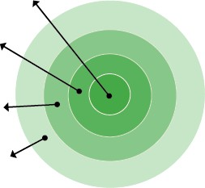
EVERYDAY HELPERS

OCCASIONAL HELPERS

POTENTIAL HELPERS

- My Family:

- Everyday Helpers:

- Occasional Helpers:

- Potential Helpers:

- My Family: List who lives in your house.
- Everyday Helpers: Identify who you can call on to help drop your child off or who can pick your child up when you cannot. These are people like friends, neighbors and relatives who can help regularly.
- Occasional Helpers: Identify people who probably cannot help every day but can help in a pinch. Maybe it’s a godparent, a relative or a friend who lives outside your neighborhood but can be there for short stints.
- Potential Helpers: Identify people who are part of your school community, place of worship or neighborhood who are able to help — if you ask.

If I need help getting my child to and from school, I will ask the following people to be our backup:

Name: Best Contact Number:

Name: Best Contact Number:

Name: Best Contact Number:

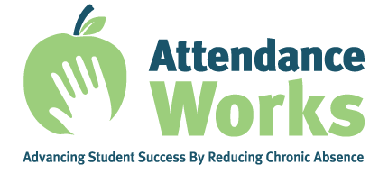

To learn more, please visit www.attendanceworks.org
Adapted from materials created by Early Works at Earl Boyles Elementary School
in Portland, Oregon (http://www.childinst.org/our-initiatives/early-works) rev. 9-8-21
