District Transitions Planning Worksheet
For the Covid-19 Era

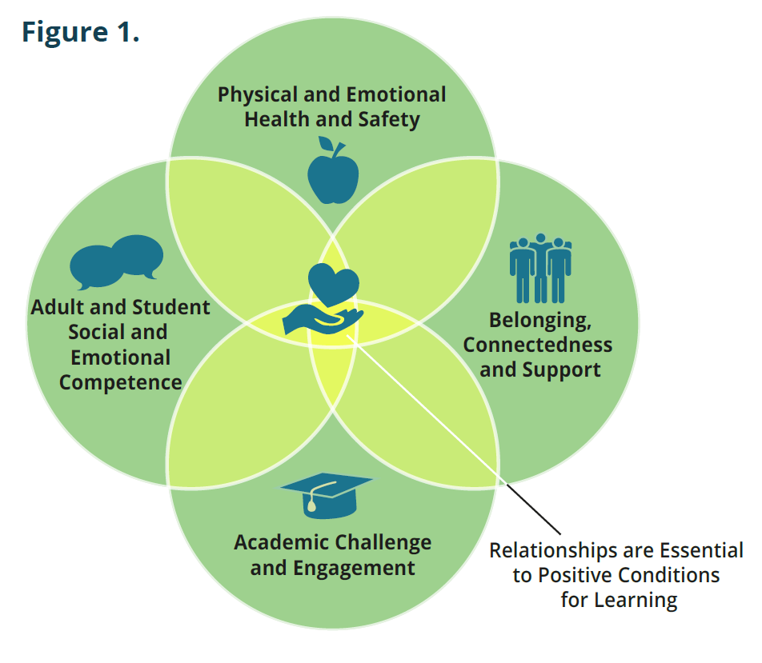
Purpose of the worksheet
Data on attendance and absenteeism are essential tools for creating a thoughtful plan for managing multiple school transitions. Data sheds light on where additional investments are needed to ensure positive conditions for learning (See Figure 1) are in place to motivate students to show up to school regardless of whether classes are offered in person, through distance learning or in some other form.

How to use this worksheet
This worksheet poses six key questions for district leaders to answer as they prepare a plan for managing multiple school transitions. It supports each district creating a plan tailored to their realities, especially since the impact of Covid-19 varies across the country. It emphasizes understanding and inviting feedback from the students and families most impacted in your district (i.e. Black Americans, Latinx, Native Americans, and students with disabilities, living in low-income rural communities and involved in public systems) to ensure the plan addresses their needs.

The worksheet is intended to help district leaders. It can be used to address urgent issues and some of the factors that need to be considered as you revise, adapt and develop a plan for the fall semester and subsequently a year-long transition plan. To learn more about the underlying concepts, read our Present, Engaged and Supported: District Transition Planning Guide.

This worksheet is not meant to be an in-depth analysis of a district’s system. For a more intensive analysis, consider piloting the District Transition Attendance Analysis Tool included in Present, Engaged and Supported: District Transition Planning Guide.

As district leaders, we suggest you discuss each question and how your district is responding. Use the blank worksheet on page 3 to keep track of what you are already doing. Then identify and address additional priorities that may be missing that require action.

Finally, we offer these resources which you may find helpful as you determine priorities for action:

- Monitoring Attendance in Distance and Blended Learning by Attendance Works
- Attendance Playbook: Smart Strategies for Reducing Chronic Absence in the Covid Era by Future Ed and Attendance Works
- When Learning Starts: Playbook for Healthy School Communities by Kaiser Permanente
- Guidance on Culturally Responsive Sustaining Remote Education Centering Equity, Access, and Educational Justice for more information visit
New York State Department of Education’s resources on this topic.

Key Questions | Priorities for Implementation (District)
- Do we have a team with responsibility for transition planning in place? | - Establish or expand a cross-functional, cross-departmental team that includes those who understand the district’s attendance and discipline systems, to craft, monitor and oversee the implementation of the transition plan.  - Ensure the perspectives and experiences of students and families inform the plan, especially those most affected by Covid-19 and existing educational inequities.  - Engage site administrators and school staff in the design of the implementation plan.  - Gain the support of key groups including unions, municipal leaders, local funders and community partners.
- What will our district do to provide a physically and emotionally healthy environment that emphasizes restorative and trauma-informed practices for the current school year? | - Define the steps to prevent and mitigate the spread of Covid-19.  - Map district, school and community-based behavioral and mental health services and teams.  - Ensure schools have the resources to promote a positive school climate and culture whether that is in-person, hybrid or virtual.  - Train staff to recognize and respond to trauma and stress-related behaviors and to use restorative practices.  - Ensure time to offer these activities is reflected in master schedules and plans for professional development.  - Provide PD to instructional and non-instructional staff to address the disparate impact of Covid-19 on students and families who are Black Americans, Latinx, Native American, and students with disabilities, living in low-income rural communities, and involved in public systems.
- Based on data, can we anticipate which groups of students are in need of additional support? | - Analyze pre-Covid-19 district attendance data by school, grade, race/ethnicity, home language, disability and zip code.  - Determine how many students and families that staff were unable to contact during school closure and reach out to them.  - Disaggregate quantitative and qualitative data to understand which students are not regularly participating in distance learning and reach out to them to identify what is keeping them from participating (including lack of connectivity).  - Provide data to school teams or ensure access to data every week.  - Offer schools a standard needs assessment to use to update and identify barriers to attendance and participation.
- Do we have systems in place and interventions to ensure the students with significant needs receive the support and resources they need to connect and re-engage? | - Enhance the capacity of school teams to organize and facilitate a school-wide multi-tiered attendance strategy.  - Provide guidance to school teams to implement interventions in response to Covid-19.  - Put in place consistent protocols and strategies that equip schools to meet the unique needs of students in key transition grades (K, 6th, 9th and 12th).  - Provide schools with reports that transfer student attendance and participation history to the receiving schools.
- Do we have a plan for monitoring attendance in the current school year? | - Expand attendance monitoring to include measures like contact, connectivity, participation and relationships.  - Put in place new processes to ensure updated contact information for every family.  - Create a district-wide plan to identify and address connectivity issues for students and staff.  - Determine how to measure participation in distance learning and align with state guidance.  - Give clear directions to schools on how to take daily attendance in 2020-2021, enter it into the SIS system, track by modes of instruction (in-person, synchronous, asynchronous) and ensure consistency.  - Ensure schools monitor absences for both in-person and distance learning in 2020-2021 and use the data for early warning.
- Do we have a comprehensive, centralized communications strategy? | - Communications are targeted and accessible to diverse stakeholders (e.g., families, students, community partners, etc.)  - Create a year-long communications plan and calendar for timely, accessible communications about school operations, class schedules, available resources with provisions for modifying as needed.  - Establish protocols to maintain two-way communication with families and with staff.  - Make sure families are informed in home language when students are absent or not participating in distance learning.

Key Questions | Priorities for Implementation (District)
- Do we have a team in place with responsibility for transition planning?

- What will our district do to provide a physically and emotionally healthy environment that emphasizes restorative and trauma-informed practices for the current school year?
- Based on data, can we anticipate which groups of students are in need of additional support?
- Do we have systems in place to ensure the students with significant needs receive the support and resources they need to connect and re-engage?
- Do we have a plan for monitoring attendance in the current school year?
- Do we have a comprehensive centralized communications strategy?

