Attendance Pyramid Worksheet

 | Family Engagement | Positive Student Engagement | Behavioral and Mental Health | Physical Health | Academic Support | Extended Learning | Basic Needs
Tier 3: Intensive Intervention

Tier 2: Early Intervention

Tier 1: Universal Prevention

Foundational Supports

https://www.attendanceworks.org/chronic-absence/addressing-chronic-absence/3-tiers-of-intervention/
Adapted from format created by Nancy Erbstein, Associate Professor of Education in Residence, with the UC Davis Center for Regional Change and Sacramento City USD.

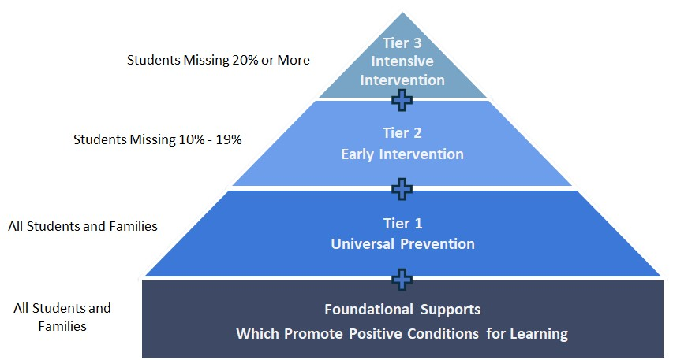
Tier 3

#__________
Tier 2

#__________
Tier 1 and
Foundational Supports

#__________
How many students
are in each group?

