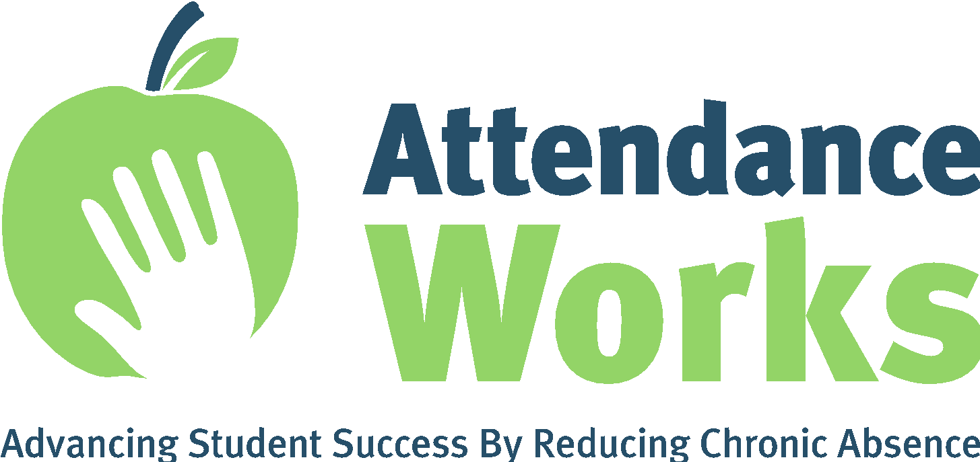
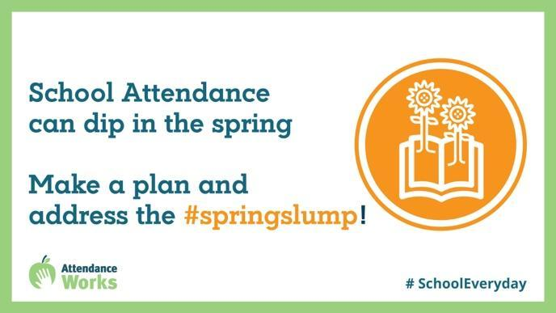
Sample Twitter Posts
Ever noticed that student attendance drops in the spring & continues downward until the end of school? By preparing for the #SpringSlump, schools & teachers can implement strategies to encourage attendance & participation. Find resources: https://www.attendanceworks.org/resources/spring-attendance-slump/
During the typical #SpringSlump attendance drops.The pandemic exacerbated existing student barriers to attendance while also introducing new ones. Active attention to these barriers can help us improve attendance: https://www.attendanceworks.org/resources/spring-attendance-slump/ #SchoolEveryDay
To curb the #SpringDip, organize opportunities for students to learn outside the classroom or via virtual field trips to zoos, planetariums, local farms, historical sites or museums. https://www.attendanceworks.org/resources/spring-attendance-slump/ #SchoolEveryDay
Check out @attendanceworks calendar and handout with sample activities to help keep attendance strong during the spring months. https://www.attendanceworks.org/resources/spring-attendance-slump/ #SpringDip #SchoolEveryDay

Sample FACEBOOK Posts

- Have you noticed that daily attendance drops around the spring break and often continues downwards through the end of the school year? When educators are aware of this ‘Spring Dip’ they can make a plan to address the absences and engage students.

Attendance Works has developed ideas for curbing the Spring Dip, such as organizing a spirit week, implementing a mentor program, scheduling culminating events, shows, and showcases for the very end of the year and more.

Check out the Attendance Works website page with a sample calendar of sample activities, a handout and more inspiration! https://www.attendanceworks.org/resources/spring-attendance-slump/

- The “Spring Attendance Dip” results from a combination of factors, while the pandemic exacerbated existing student barriers to attendance and introduced new ones. Active attention to these obstacles can help us to reduce absences at any time of the school year.

Check out Attendance Works’ calendar of sample activities, a handout and more inspiration! https://www.attendanceworks.org/resources/spring-attendance-slump/

