My Family’s Help Bank
Create Backup Plans for Getting to School
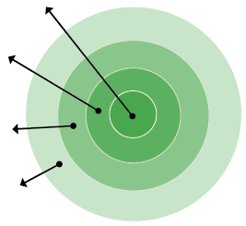
Everyday
helpers
Everyone needs a buddy sometimes.
Plan ahead to make life easier.
My family
Potential helpers
Occasional helpers
- My family: Anyone who lives with you who can help on a regular basis. Avoid using older children if it causes them to miss school.
- Everyday helpers: Nearby friends, neighbors and relatives who might share to and from school duty regularly.
- Occasional helpers: A godparent, relative or friends you might be able to call on once in a while for a special need.
- Potential helpers: Ask your teacher, school, neighborhood organization or place of worship for introductions to others who can occasionally help get students to and from school.

- My family:
- Everyday helpers:
- Occasional helpers:

- Potential helpers:
If I need help getting my child to and from school, I will ask the following people to be our backup:

Name: Best Contact Number:
Name: Best Contact Number:

Name: Best Contact Number:
October 2025 www.attendanceworks.org

