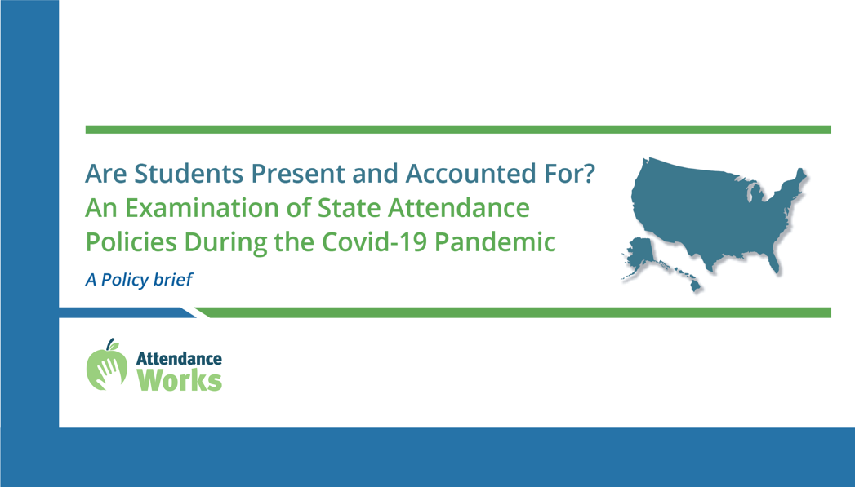

Sample Tweets

NEW! @attendanceworks’ latest report offers 7 recommendations for how states can offer guidance that guarantees the continual availability of #chronicabsence data as a tool to support students & families in #SchoolEveryDay https://www.attendanceworks.org/are-students-present-and-accounted-for-an-examination-of-state-attendance-policies-during-the-covid-19-pandemic/
#StatesLeading #RemoteLearning

Daily attendance data acts as a warning sign that additional outreach & resources are needed to support students & their families during #COVID19 & beyond. Learn more @attendanceworks https://www.attendanceworks.org/are-students-present-and-accounted-for-an-examination-of-state-attendance-policies-during-the-covid-19-pandemic/ #SchoolEveryDay #remotelearning

NEW! @attendanceworks just released a scan showing how all 50 states + D.C. are taking attendance during #Covid19, w/ recommendations for action. https://www.attendanceworks.org/are-students-present-and-accounted-for-an-examination-of-state-attendance-policies-during-the-covid-19-pandemic/ #SchoolEveryDay #StatesLeading

Facebook or Newsletter
A new report from Attendance Works, Are Students Present and Accounted For? An Examination of State Attendance Policies During the Covid-19 Pandemic, discusses how the coronavirus pandemic impacted attendance data, presents an online summary of state attendance guidance developed since spring 2020, and examines the extent to which recent state guidance guarantees the availability of consistent, reliable data taken on a daily basis. It includes seven action steps for states. Find the report: https://www.attendanceworks.org/are-students-present-and-accounted-for-an-examination-of-state-attendance-policies-during-the-covid-19-pandemic/

