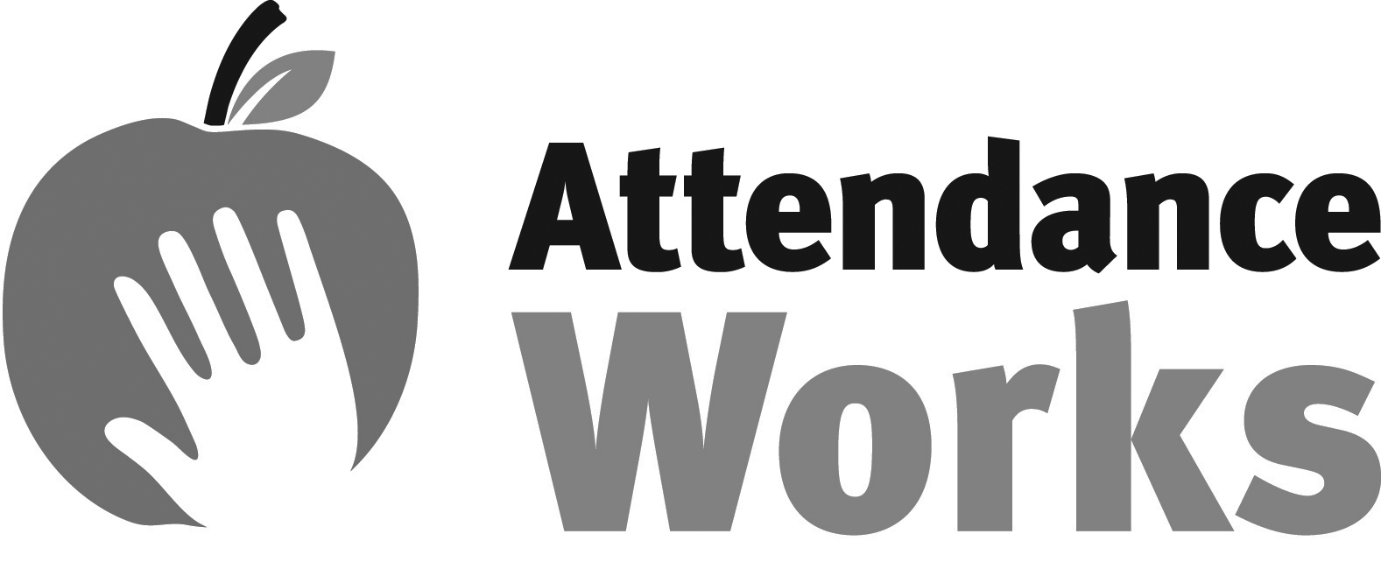
TIERS OF INTERVENTION TO
REDUCE CHRONIC ABSENCE

OVERVIEW
This hand out is intended to help a school or district think about alignment between its strategies and level of student need. The list of strategies is not exhaustive but suggestive and intended to inspire your own ideas about what could be in place.

STRATEGIES
The columns represent three tiers of strategies. Tier I Strategies are Universal Strategies that should be available to every student in a school building. Tier II Strategies are aimed at early intervention and designed to help students who need slightly more support to avoid chronic absence. Tier III Strategies are intensive supports offered to the students facing the greatest challenges to getting to school. Our assumption is that all levels of strategies involve some level of these core ingredients: A. Monitor data, B. Engage students and families, C. Recognize good and improved attendance, D. Provide personalized outreach and E. Remove barriers.

LEVELS OF STUDENT NEEDS
This chart assumes that students can be divided into tiers reflecting the level of anticipated need for supports:

Tier 1 = students whose good attendance could be maintained and cultivated as long as the universal, prevention oriented supports are in place.

Tier 2 = students who have a past history of moderate chronic absence (missing 10% or more of school) or face a risk factor (e.g. a chronic illness like asthma) which makes attendance more tenuous and need a higher level of more individualized support in addition to benefiting from the universal supports.

Tier 3 = students with several levels of chronic absence (missing 20% or more of school in the past year or during the first month of school) and/or face a risk factor (like involvement in the child welfare or juvenile justice system, homelessness or having a parent who has been incarcerated).
 | TIER 1  Missing Less than 10% of School | TIER 2  At Risk of Missing 10-19% of Days | TIER 3  At Risk of Missing 20% or more Days
A. Monitor Data | - Create a school team that regularly reviews attendance data for trends for all students and identify how many and which students fall into the different tiers of needed support  - Establish a school plan for reducing chronic absence based on an analysis of strengths and challenges around school climate and attendance practice  - Use qualitative and quantitative data to identify common barriers to attendance | - Review attendance every week for students who are chronically absent or at risk of chronic absence (due to chronic absence in the past or existence of a health challenge such as asthma). Look for patterns in attendance  - Look for qualitative data to assess the underlying cause for a student’s continued absences  - Evaluate whether students with persistent chronic absence need an appropriate tier 3 response | - Identify which and how many students have a history of missing 20% or more of school and or at risk due to other major challenges (involvement in child welfare, juvenile justice, homelessness etc.)  - Review attendance daily and ensure that Tier III students are in school each day. Follow up on each absence for each student identified for tier III intervention
B. Engage students and parents  B. Engage students and parents (Continued) | Create a school climate that encourages students to come to school everyday  - Provide an engaging curriculum that draws students to school  - Keep school clean and clear of health hazards that contribute to asthma and respiratory disease  - Cultivates an atmosphere where students feel respected and safe  - Offer programs before and after school to engage students  - Provide enrichment activities for students, such as field trips, assemblies, and dances  Create a welcoming culture of attendance  - Greet students and families at the door in the morning  - Reinforce positive, welcoming experience in the front office  - Create visuals (bulletin boards, banners, posters) that reflect attendance messaging and modify during the year to sustain impact  - Explain expectations for attendance, and how absences can add up, in back-to-school materials and at events  - Tell parents how to report an absence  - Ensure that your school has opportunities for parental engagement and involvement including organized parent groups, learning at home, and volunteer opportunities  Provide activities that engage students and families  - Offer opportunities for before and afterschool programs at the school  - Offer field trips, dances, assemblies, book fairs and other activities  - Call when students miss school to express concern  - Welcome students back and identify any academic support needed. | Provide information and attention that underscores concern for children  - Call or send letter to alert family to attendance concerns and explore what help may be needed. (If possible, use a nurse to make contact especially for student with a medical condition)  - Suggest a home visit and/or conference to address barriers to attendance  - Use the Student Attendance Success Plan to help develop family strategies to support improved attendance  - Provide parents with family-friendly, easy-to-understand information and/or assistance in reaching out to social services or community resources that may be helpful in addressing barriers identified  - Help parents understand and avoid legal consequences of extreme chronic absence  - Nurture teacher interest and capacity in helping to reach out to chronically absent students and their families  Identify and provide for family needs e.g. food pantry, clothing assistance, and literacy programs  Maintain contact with family to ensure they are receiving needed support.  Identify academic needs of the student and develop a plan to provide appropriate tutoring and coaching services.  - Determine if the student has make up work that is needed to keep up their grade point average and ensure the student and their family understand what make up work is due | Assess student and family needs and intensify outreach  - Determine if the student and their family is or should be agency involved. If they are, work to set up a meeting to coordinate services  - Refer students and families to appropriate service agencies e.g. social services, human resources, counseling, housing, and health services  - Work with relevant agencies to develop a comprehensive educational plan that also address student and family needs  - Share data with appropriate agencies and ensure that agencies are using chronic absence as a must respond to indicator  - Work with families to avoid legal consequences to the extent possible  If necessary, leverage the power of the courts to involve families and students in needed services and interventions  - Determine if the Courts have access to additional programs or services that would assist the family in overcoming barriers to attendance  Work to ensure that the student is connected to positive supports and programs, e.g. mentoring  Utilize lessons learned from working with families and students in tier three to inform tier one and two prevention and intervention efforts.
C. Recognize Good & Improved Attendance | - Create friendly competition among classrooms offering raffles, parties and public recognition for good and improved attendance  - Celebrate individual progress through weekly, monthly and periodic recognition using bulletin boards, certificates, verbal and written acknowledgement)  - Recognize students and parents at special assemblies | Establish specific individual goals and provide recognition as they are met.  - Work with students and families to set attendance goals and time frames  - Engage students in tracking their own attendance daily  - Recognize good and improved attendance weekly  - Develop strategies with students based on age, interest and other factors | Incorporate appropriate positive reinforcements into plans for supporting the student’s improved attendance.
D. Provide Personalized Early Outreach | - Place calls home each day that a student is absent  - Include attendance on report cards and in report card conferences  - Integrate information about chronic absence into parent programs and communications throughout the year  - Host a transition meeting (i.e. incoming kindergartners and families new to the school) with incoming families to help them learn about their child’s new school, get to know their teachers, and to set expectations about attendance including clearly communicating how absences can add up and impede learning, along with helping families to understand all of the learning that happens in the early grades | - Assign student an attendance buddy  - Recruit students for engaging afterschool activities. Provide morning check-ins for students  - Schedule Parent/School Staff Conference to discuss absences (Principal, Vice Principal, Teacher, Guidance Counselor, etc.)  Assess student and family needs  - Refer families to appropriate services e.g. social services, human resources, housing, and health services  - Arrange transportation to and from school with other families or staff  - Makes home visits and connect families with needed resources  - Work with students and families to develop strategies for improved attendance | - Ensure continued positive and regular contact with the family  - Check in on agreements at appropriate intervals  - Follow through on commitments of support to the family  - When the student misses school ensure assigned personnel is following up on each absence
E. Remove barriers to attendance | Invite parents and community members to help address the barriers that keep children from attending school. Strategies could include:  - A school breakfast program and/or food pantry to address hunger and nutrition needs  - A safe walk to school program to address community safety  - Health interventions such as flu shots, dental checkups and asthma management plans  - A clothing drive for winter coats or school uniform exchange  - Adoption of a school climate initiative aimed at improving approaches to student discipline and creating a more welcoming environment | - Identify barriers to attendance, such as health, transportation or housing  - Involve public agencies and community partners and resources as needed to address barriers to attendance  - Involve the school nurse with follow-up on medical related absences  - Provide families with information on community resources that can help overcome barriers  - Connect families with school-based resources that can support good attendance | - Implement agreed upon family intervention plan. Monitor for progress  - Connect students with chronic physical and mental health issues to medical providers

