

Data Matters: Using Chronic Absence Data to Accelerate Student Success.

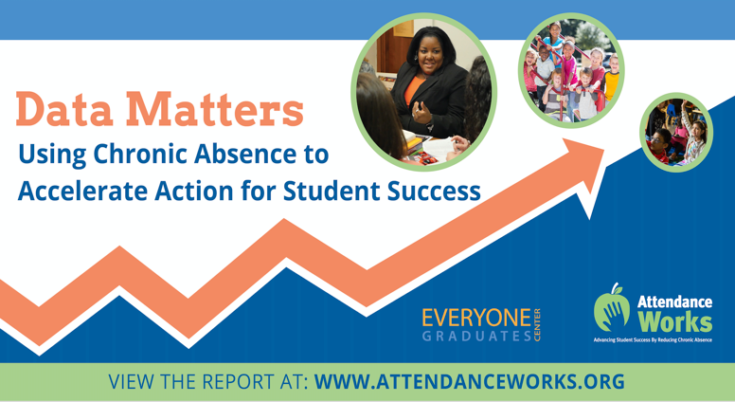

**Newsletter Blurb or Facebook Post**

A new report, *Data Matters Using Chronic Absence to Accelerate Action for Student Success*, released by Attendance Works and the Everyone Graduates Center, provides a national and state analysis of how many schools face high levels of chronic absence. Based on data released by the U.S. Department of Education’s Office for Civil Rights, the analysis compares differences in school chronic absence levels from the 2013-14 and 2015-16 school years, while showing the connection between chronic absence levels and demographics. The report shares tools for unpacking the causes of chronic absence and provides recommendations for action. State data reports and an interactive map from The Hamilton Project at the Brookings Institution allow anyone – from parents to policymakers – to explore the scale of the chronic absence at multiple levels: school, district, state and country. Find the report: <https://bit.ly/2wusNE9> Join an Attendance Works webinar to learn more, on Sept 12 at 2 p.m. ET. Register here! https://adobe.ly/2MumH0v

**Twitter**

The new report Data Matters @attendanceworks @JHU_EGC shows how you can use #chronicabsence data to interrupt patterns of inequity & improve outcomes for all kids, particularly our most vulnerable Ss, who deserve an equal opportunity to learn & thrive! https://bit.ly/2wusNE9 #SchoolEveryDay

Everyone using #chronicabsence data, from administrators to teachers to elected officials & community orgs., needs to make sure data is used to activate positive problem-solving, not blame. Learn more @attendanceworks @JHU_EGC report, Data Matters https://bit.ly/2wusNE9 #SchoolEveryDay

#Chronicabsence data is a powerful tool that can be used to unpack barriers to being in #SchoolEveryDay. Learn more from Data Matters, the new report @attendanceworks @JHU_EGC: https://bit.ly/2wusNE9 @laurenlbauer

New analysis @attendanceworks @JHU_EGC @laurenlbauer shows nearly 8 million, or 15% of all students, miss 10% or more of the school year. But the rates vary widely by state & within states. Learn more in Data Matters https://bit.ly/2wusNE9 #SchoolEveryDay

New report, Data Matters, includes tools for unpacking the causes of chronic absence & has recommendations for action, from @AttendanceWorks & @JHU_EGC https://bit.ly/2wusNE9 #schooleveryday

The key to using #chronicabsence data is avoiding blame & addressing barriers to #schooleveryday https://bit.ly/2wusNE9 @JHU_EGC @attendanceworks

**Webinar 9/12/18**

Join @attendanceworks' final AAM webinar, Team Up for Attendance: Data Matters, on 9/12/18!  We'll share highlights of a new nat'l & state analysis of schools w/ high levels of #chronicabsence with @hamiltonproj @JHU_EGC Register: https://adobe.ly/2MumH0v  #SchoolEveryDay

Not sure how #chronicabsence data, soon to be in your state's report card, can be used to address this pernicious issue? Learn tips for using data to take action @hamiltonproj @JHU_EGC @Munoz4Youth @SenBillFerg Register: https://adobe.ly/2MumH0v #SchoolEveryDay

Join @attendanceworks' final AAM webinar, Team Up for Attendance: Data Matters, on 9/12/18!  We'll share highlights of a new nat'l & state analysis of schools w/ high levels of #chronicabsence with @hamiltonproj @JHU_EGC Register: https://adobe.ly/2MumH0v  #SchoolEveryDay