• I have been present days.
• I have been absent days.
• My goal is to improve my attendance. I will ensure that I miss no more than ___ days for the rest of the year. (9 or fewer absences = satisfactory attendance)
[Insert your logo]

My Attendance
SUCCESS PLAN

Possible Strategies to REACH MY Attendance Goals

- I will make attending school every day a priority.
- I will keep track of my attendance and absences.
- I will set my alarm clock for a.m.
- I will attend school every day unless I’m truly sick with a temperature of 100 degrees or more.
- I will find a relative, friend or neighbor who can take me to school if I miss my bus.
- If I am absent, I will contact my teachers to find out what I missed.
- I will set up medical and dental appointments for weekdays after school. If I must make a medical appointment during the school day, I will try to attend school for the majority of the day.
- When I am struggling with a challenge that is keeping me from school I will confide in an adult at school and seek help.

To improve my attendance, I commit to the following:
1.
2.
3.

We will review progress to meet this goal in one month.

Student Signature: Date:

School Staff Signature: Date:
MY HELP BANK
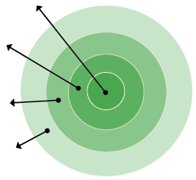
- My Family: List who lives in your house.
- Everyday Helpers: Identify who you can call on to help you get to school or resolve a problem. These are people like friends, neighbors, school staff, and relatives who can help regularly.
- Occasional Helpers: Identify people who probably cannot help every day, but can help in a pinch. Maybe it’s a godparent, a relative or a friend who lives outside your neighborhood but can be there for short stints.
- Potential Helpers: Identify people who are part of your school community, church or neighborhood who are able to help if you ask.
EVERYDAY HELPERS
OCCASIONAL HELPERS
MY FAMILY
POTENTIAL HELPERS
- My Family:
- Everyday Helpers:
- Occasional Helpers:
- Potential Helpers:
If I need help getting to and from school or with a barrier to attendance, I will ask the following people help me out:

Name: Best Contact Number:
Name: Best Contact Number:

Name: Best Contact Number:

