Newsletter Blurbs
A new report, Portraits of Change: Aligning School and Community Resources to Reduce Chronic Absence, released by Attendance Works and the Everyone Graduates Center shows there are almost 10,000 public schools across the United States – or 11 percent of the total – at which chronic student absence rates affect 30 percent or more of their students. At such high levels, all students in the classroom are affected when teachers have to deal with the churn of sporadic attendance.

Portraits of Change: Aligning School and Community Resources to Reduce Chronic Absence, also includes inspiring examples of attendance initiatives from around the country that show how chronic absence can be turned around, even when it reaches high levels. It explains how partners such as businesses, nonprofits and local governments can team up with educators to reduce chronic absence. Join a webinar on Sept 12 at 2 p.m. ET. Register here

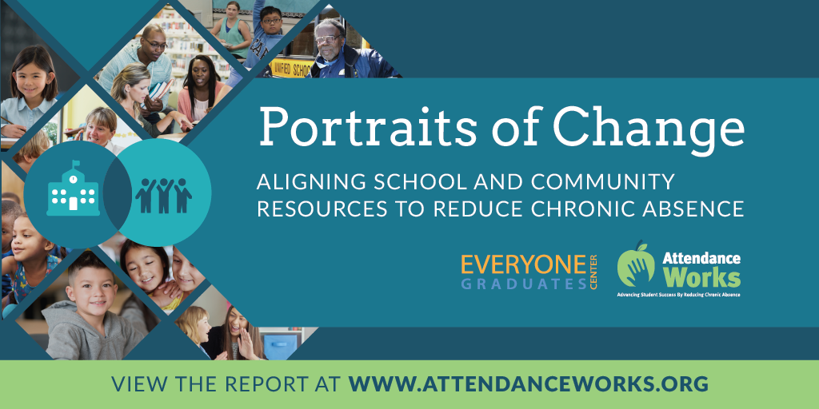
Social Media Posts

Facebook
A new analysis by Attendance Works and the Everyone Graduates Center found that overall, more than 7 million students nationwide are chronically absent from school. In one-fifth of schools, chronic student absence rates affect 20-30 percent or more of their students. At such high levels, all students in the classroom can lose out when teachers have to deal with the churn of sporadic attendance. The report profiles inspiring examples showing that chronic absence can be turned around, even when it reaches high levels. http://bit.ly/2xztw5O

Almost 10,000 public schools across the United States – or 11 percent of the total – have chronic absence rates that affect 30 percent or more of their students. A new report by Attendance Works and the Everyone Graduates Center provides a national and state analysis of how many schools face these high levels of chronic absence, and shares Portraits of initiatives that show how chronic absence can be turned around, even when it reaches high levels in a school, district or particular student population. http://bit.ly/2xztw5O

Twitter
New! #chronicabsence affects 30% of Ss in 11% of US schools http://bit.ly/2xztw5O @AttendanceWorks @JHU_EGC #SchoolEveryDay

Portraits in different states show chronic absence can be turned around #schooleveryday http://bit.ly/2xztw5O @JHU_EGC @attendanceworks

Do urban or rural schools have more students missing school? @AttendanceWorks & @JHU_EGC explain #schooleveryday http://bit.ly/2xztw5O

Key to #chronicabsence data is avoiding blame & addressing barriers to #schooleveryday http://bit.ly/2xztw5O
@JHU_EGC @attendanceworks

Low-income kids in most states are more likely to miss school than peers. @AttendanceWorks & @JHU_EGC #schooleveryday http://bit.ly/2xztw5O

9/12 webinar: How to improve chronic absence when 30% or more Ss are absent @AttendanceWorks @JHU_EGC #schooleveryday http://bit.ly/2wjXsUS

Community partners can team up w/ educators to get Ss to #schooleveryday @AttendanceWorks @JHU_EGC http://bit.ly/2wjXsUS

Find other memes and tweets for Attendance Awareness Month here.

