

• My child was absent ___ days in the prior month.

• My goal is my child will be absent no more than ____ day(s) next month.

My Child’s Attendance SUCCESS PLAN

Possible Strategies to Reach MY Child’s Attendance Goals AND HELP MY CHILD GAIN THE SKILLS TO DO WELL IN SCHOOL and TO ReAD by 3rd GRADE.

* Keep an attendance chart at home. At the end of the week, I will recognize my child for attending preschool every day with . (i.e. a visit to the park, a new book, a special treat or a hug)
* Make sure my child is in bed by p.m. and the alarm clock is set for a.m.
* Find a relative, friend or neighbor who can take my child to or from preschool if I can’t.
* Set up medical and dental appointments for weekdays after preschool.
* Use sound judgment about mild medical complaints:
* If my child complains of a stomachache or headache, and medical concerns have been ruled out, I will send him/her to preschool and ask the program to check in with my child during the day.
* If my child has a cold but no fever (less than 100 degrees), I will send him/her to preschool. If I don’t have a thermometer, I’ll let someone know I need help getting one.

To improve ______________________’s attendance, I commit to the following:

1. ____________________________________________________________________
2. ____________________________________________________________________

To improve ______________________’s attendance, the program commits to:

1. _____________________________________________________________________

2. _____________________________________________________________________

*We will review progress to meet this goal in one month*

Family Signature: Date:

Program Signature: Date:



**To learn more, please visit www.attendanceworks.org**

Adapted from materials created by [Early Works](http://www.childinst.org/our-initiatives/early-works) at Earl Boyles Elementary School in Portland, Oregon (<http://www.childinst.org/our-initiatives/early-works>)

**MY FAMILy’S HELP BANK**

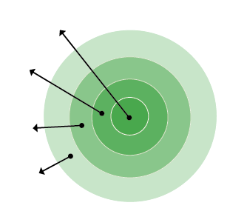

1. **My Family**: List who lives in your house.
2. **Everyday Helpers**: Identify who you can call on to help drop your child off or who can pick him or her up when you cannot. These are people like friends, neighbors and relatives who can help regularly.
3. **Occasional Helpers**: Identify people who probably cannot help every day, but can help in a pinch. Maybe it’s a godparent, a relative or a friend who lives outside your neighborhood but can be there for short stints.
4. **Potential Helpers**: Identify people who are part of your school community, church or neighborhood who are able to help if you ask.

**EVERYDAY HELPERS**

**OCCASIONAL HELPERS**

**MY FAMILY**

**POTENTIAL HELPERS**

1. **My Family**:
2. **Everyday Helpers**:
3. **Occasional Helpers**:
4. **Potential Helpers**:

If I need help getting my child to and from school, I will ask the following people to be our back-up:

**Name:** **Best Contact Number:   
  
Name:** **Best Contact Number:**

**Name:** **Best Contact Number:**